COPYMASTER | COPY TONE: professional / elite |  |  |  |  |  | VERSION: 1.0
Project Name: | Product Name: Predator Aethon 750 TKL |  |  |  |  |  | Product Type:  Magnetic Keyboard
Writer: Clark Gurden | Central MKT: Clark Gurden |  |  |  |  |  | FCS: 6/E/26
NOTE TO EDITORS: If you would like to leave feedback or a correction, do it via COMMENTS.
Do not edit copy directly.
//AGW Meta Content
Page Title (60) | PREDATOR AETHON 750 TKL | Competitive FPS Magnetic Keyboard
Meta Description (160) | Built for competitive FPS play, this magnetic switch TKL keyboard delivers adjustable actuation, rapid trigger control, an 8000 Hz polling rate, and reinforced construction for precise, stable input under pressure
//Line/Class Content
Shortened KM (120)  Series Card | Magnetic movement control and tournament-grade signal stability for competitive FPS players.
//AGW Page Content / Banner
Banner Content - Product Name/Header (40) | PREDATOR AETHON 750 TKL
Key Message/Page Intro
Key Message Headline | PRECISION YOU CAN EXECUTE ON
Key Message/Intro (250) | Built for competitive FPS play, this keyboard is engineered for players who move with intent. Magnetic switch input, rapid trigger behavior, and a focused TKL layout work together to deliver clean resets, controlled movement, and reliable execution when the margin for error disappears.
Media Reviews – ENGLISH (ENG)
Publish to USA / CA
Section Headline | Media Reviews
Text Content
Image Selection | Generic |  |  | Generic |  |  |  |  | Generic |  |  |  | Generic
Reviewer Name
Quote (180 Characters)
Button & URL | Read More |  |  | Read More |  |  |  |  | Read More
Acer KSP 1
Image Reference | 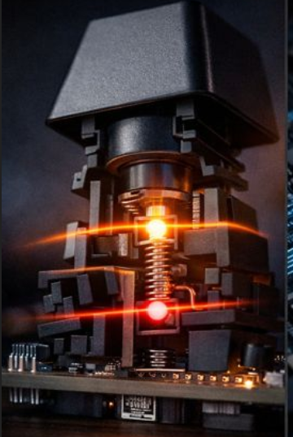
KSP Headline (40) | MAGNETIC CONTROL FOR FPS MOVEMENT
KSP Body (220) | Movement in competitive FPS is not about speed alone. It’s about control. Magnetic switch input allows for cleaner resets and more deliberate movement, helping players maintain tight strafing and directional accuracy when every correction matters.
Spec (40) | ACTUATION: 0.1–3.0 MM |  | RAPID TRIGGER BEHAVIOR |  |  |  |  | PREDATOR MAGNETIC SWITCHES |  |  |  | ADJUSTABLE ACTUATION
Underline (30) | Input Depth Control |  | Instant Reset |  |  |  |  | Contactless Design |  |  |  | Sensitivity Tuning
Acer KSP 2
Image Reference | 
KSP Headline (40) | 8,000 HZ POLLING FOR TOURNAMENT PLAY
KSP Body (220) | In high-pressure play, consistency matters more than peaks. Stable signal delivery and precise input timing ensure commands register when intended, allowing players to trust every movement and commit without hesitation.
Spec (40) | 8,000 HZ POLLING RATE |  |  |  | N-KEY ROLLOVER |  |  |  |  | LOW-LATENCY WIRED MODE
Underline (30) | Signal Frequency |  |  |  | Multi-Key Accuracy |  |  |  |  | Wired Reliability
Acer KSP 3
Image Reference | 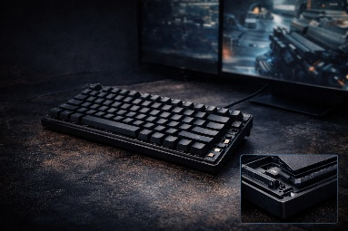
KSP Headline (40) | TKL DESIGN FOR COMPETITIVE SETUPS
KSP Body (220) | The tenkeyless layout keeps the desk clear and the focus tight. Reinforced construction and a controlled keystroke feel support long sessions without distraction, built for players who stay sharp deep into the match.
Spec (40) | TENKEYLESS 87-KEY LAYOUT |  | GASKET MOUNT STRUCTURE |  |  |  |  | 2.4 GHz WIRELESS |  |  |  | BLUETOOTH® CONNECTIVITY
Underline (30) | Desk Efficiency |  | Structural Tuning |  |  |  |  | Wireless Freedom |  |  |  | Device Pairing
//Packaging Copy
FEATURE (NOT FOR USE) |  | HEADLINE (ALL CAPS) |  |  |  | BENEFIT |  |  |  |  | BULLETPOINT
Magnetic Switch Technology |  | MAGNETIC MOVEMENT CONTROL |  |  |  | Enables precise movement control. |  |  |  |  | Magnetic Switch with Adjustable Actuation
High Polling Performance |  | 8,000 HZ SIGNAL STABILITY |  |  |  | Maintains consistent input timing. |  |  |  |  | 8,000 Hz Polling Rate
Competitive Layout Design |  | TKL COMPETITIVE LAYOUT |  |  |  | Frees space for mouse movement. |  |  |  |  | Tenkeyless 87-Key Layout
Keystroke Structure |  | CONTROLLED KEY FEEL |  |  |  | Delivers consistent keystroke response. |  |  |  |  | Gasket-Mounted Keyboard Design
Input Accuracy Assurance |  | FULL ANTI-GHOSTING |  |  |  | Registers every keypress accurately. |  |  |  |  | N-Key Rollover
Connection Method |  | WIRED TO COMPETE |  |  |  | Ensures stable wired performance. |  |  |  |  | USB Wired Connection

